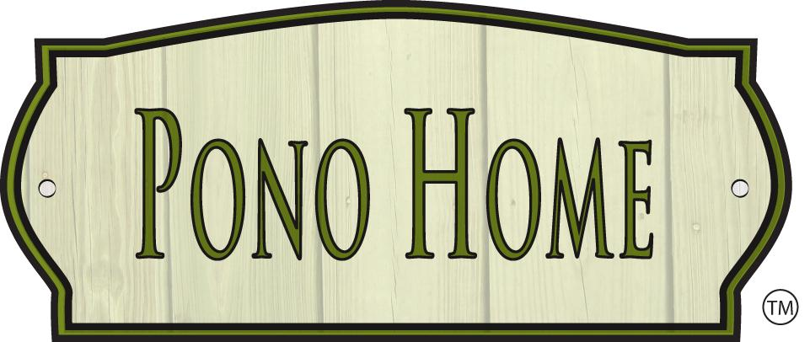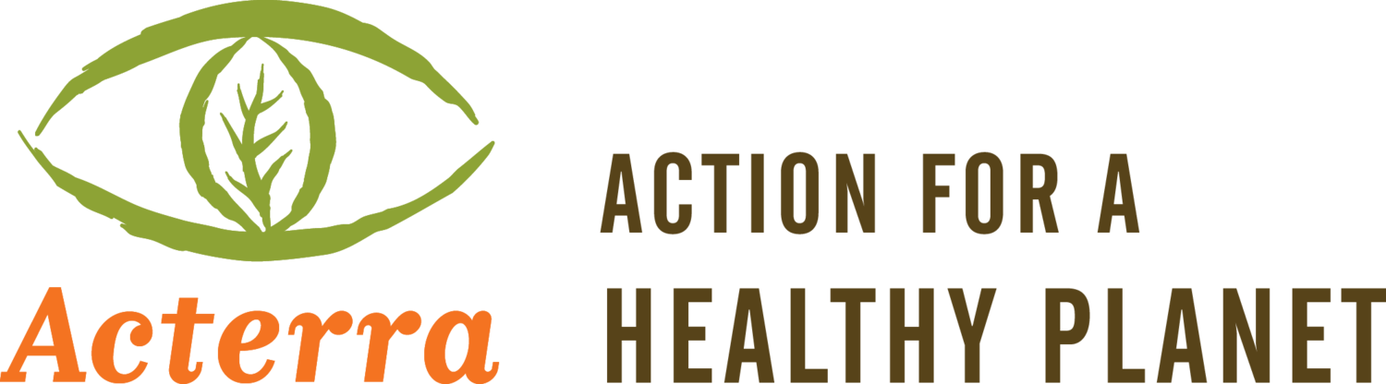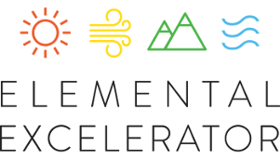

Train to Own Your Own Green Business!

Pono Home, in partnership with Acterra and Elemental Excelerator, announces a career training program for an aspiring green entrepreneur located in the East Palo Alto area and surrounding communities. The selected candidate(s) will train with Pono Home and Acterra and community partners to learn how to provide free, comprehensive home efficiency services to 100 to 150 low- and moderate-income families in East Palo Alto and neighboring communities from July-December 2018. Upon successful completion of the project at the end of the year, the selected candidate(s) will be eligible to apply for a free Pono Home franchise and additional training with Pono Home staff so they can start a green business with no up-front costs and continue to provide services in the area with an expanded scope of work. Entrepreneurs are welcome to apply alone or with a partner.

This career training program provides a supportive pathway for an entrepreneur to earn a living greening homes in their community, own their own green business, and pioneer the expansion of an innovative business from Hawaii into California. This is a paid, flexible position, and the selected candidate(s) will be paid for all hours worked during the training period.

About Pono Home
Pono Home is a sustainability-focused, Certified B Corporation® focused on greening lives, homes and small businesses, with the mission of making sustainability accessible, easy, affordable, and convenient for all. Pono Home technicians audit a home using custom software with a 200+ point checklist to identify ways to reduce electricity and water usage, and then provide eco-upgrade installations, appliance maintenance, and education in a comprehensive home efficiency service to help people save money and live greener and healthier, for life!

Pono Home was selected for the Elemental Excelerator’s 2014 Go-To-Market track and the 2016 Demonstration Track, and was awarded the Just Innovation Prize to expand into the East Palo Alto area in 2018. Since opening in 2014, the company has greened more than 6,000 homes across the Hawaiian islands. More than 2,000 homes were serviced in 2017, with estimated annual savings of over $550,000 on utility bills, 26 million gallons of water and roughly 3 million pounds of carbon dioxide emissions. Pono Home has also recently released a line of organic personal care products with a zero-waste innovation that it has begun marketing and testing on Oahu and soon in Las Vegas. The company is expanding through franchising.

Position Overview

Desired Qualifications

To perform this job successfully, an individual must be able to perform each essential duty satisfactorily. The ability to lift up to 50 pounds regularly and without assistance, as well as the ability to use power and other tools safely and reach tight spaces that may require climbing a ladder/stepstool and getting down on hands and knees are critical requirements of this position. In addition, candidate must be able to:
- Communicate the process, tasks, and outcomes effectively with customers, preferably in fluent English and Spanish
- Attend meetings as appropriate and meet regularly with supervisors and project partners to exchange pertinent information and to receive supervision
- Use power and other tools to perform hardware installations on plumbing fixtures and light bulb replacements
- Interact appropriately with any and all customers, family members, care providers of residents, and project partners
- Educate clients one-on-one in a home setting
- Accurately use and derive readings from various cleantech auditing devices
- Maneuver tight and sometimes damp spaces with acuity sufficient to avoid accidents
- Assist with inventory and general maintenance of supplies, facilities and equipment
- Interact with clients in a confidential, and responsible manner maintaining a high level of ethical conduct
- Lack debilitating allergic reaction to common household allergens, including but not limited to pet dander, dust mites, and other airborne allergens
- Lack debilitating chemical sensitivity to chemical gases frequently found in homes
- Put forth a welcoming personality capable of interacting with new potential customers in a way that makes people feel comfortable
- Maintain detailed customer records and follow up with potential customers
- Represent the company at public events and at all times put forth a professional appearance
- Handle payment processing
- Scheduling of customer visits and upkeep of customer database
- Perform other duties as assigned

Desired Qualifications/Requirements
- High School diploma or equivalent plus two years of relevant paid or voluntary experience OR Associate degree required
- Oral and written communication skills. Fluency in Spanish is preferred but not required
- Knowledge in educating clients in daily living skills
- Observation and decision-making skills
- Demonstrated ability to work independently and without ongoing supervision, including scheduling, and especially timeliness
- Potential willingness to use personal transportation in work capacity, with reimbursement paid for miles driven
- Knowledge of sustainability issues or related work experience would be beneficial
- Experience managing a project or overseeing employees

Certificates, Licenses, Registrations
- Driver’s license, including clean driving record

Physical Demands
The physical demands described here are representative of those that must be met by an employee to successfully perform the essential functions of this job. Reasonable accommodations may be made to enable individuals with disabilities to perform the essential functions.
- Lifts and carries up to 50 pounds
- Safely loads and unloads cargo from work vehicle
- Climbs stairs and/or ladder and safely work on a ladder for brief periods
- Gets down on hands and knees
- Working hours rotate quickly

Conditions of Award
- Satisfactory reference and background investigation checks
- Satisfactory completion of training and all required paperwork
- Attendance at all mandatory staff development & training

Compensation
This position is flexible, and may be part-time or full-time. Compensation is competitive and based on experience. Commissions are available to earn for each item installed in a home.

Training
Training for the selected candidate(s) will be in East Palo Alto and Menlo Park, California. Applicants should live in or nearby East Palo Alto, or live within daily commuting distance. Training is tentatively scheduled for July 25-27, and candidates should be available these dates.

How to Apply
Pono Home and Acterra will hold an info session on July _ in Palo Alto for interested applicants to learn more about the opportunity.

Interested candidates should send a resume and cover letter to info@ponohome.com. The deadline to apply is 5 p.m. PT on Monday, July 16. For more information on the franchise application process at the end of the project, please visit ponohome.com/justinnovation to download the Franchise Application

Project Partners

About Acterra
Acterra is a San Francisco Bay Area 501(c)(3) nonprofit based in Palo Alto that brings people together to create local solutions for a healthy planet. Acterra focuses on what you can do locally to address current environmental problems. In the face of daunting environmental challenges, Acterra’s science-based approach instills hope while building community. Acterra's staff provides environmental education in the areas of energy and climate change, corporate sustainability, and advocacy to build an informed and empowered citizenry. Acterra’s programs engage people and companies in the Bay Area, with a focus on Santa Clara and San Mateo counties.
About Elemental Excelerator
Elemental Excelerator is a nonprofit created in collaboration with Emerson Collective, an investment and philanthropic platform. Elemental Excelerator works collaboratively with Emerson Collective’s Elemental practice, which focuses on strengthening the relationship between humanity and nature through scalable, equitable, and innovative solutions. Elemental Excelerator is funded by the U.S. Navy and a diverse coalition of utility partners, corporate partners, the U.S. Department of Energy, state government, and philanthropic organizations. Their goal is not only to curate a portfolio of innovative and impactful startups, but also to build an ecosystem of passionate people working to change the world, one community at a time.

